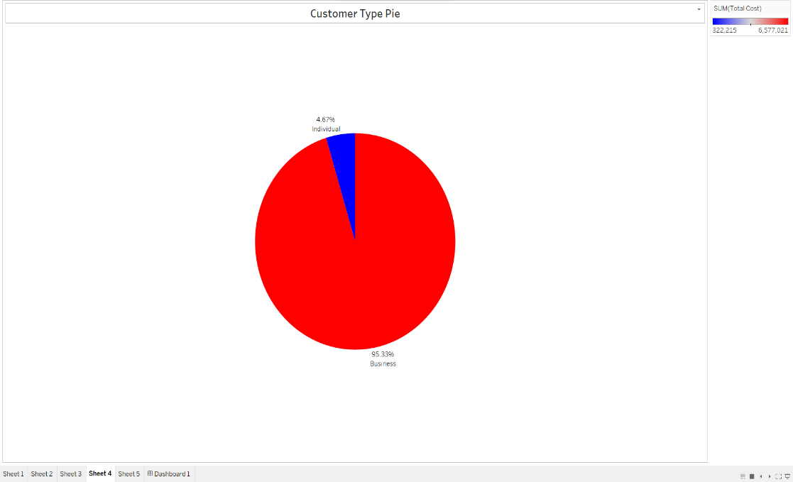

Customer Type Pie chart :

* Decide whether Individuals or businesses total costs are higher to increase dealings with them.
* 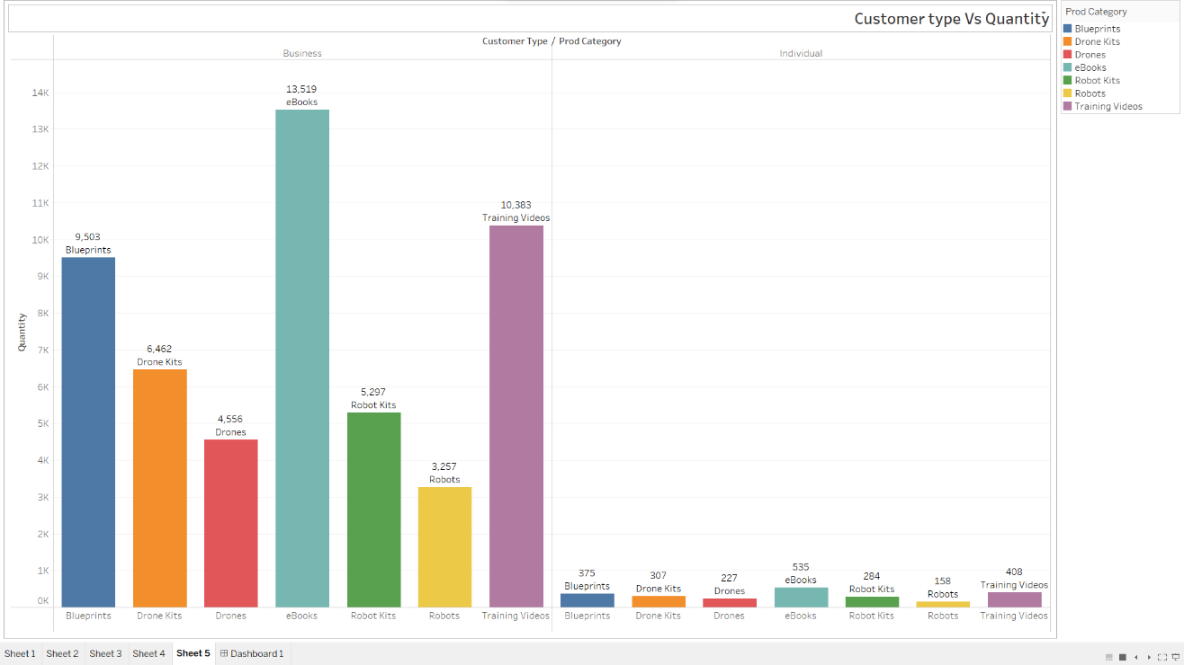Pie chart – Red and Blue – Percentage legends and title.

Customer type VS Quantity Bar chart :

* Will help to decide which customer type buy more things and which item they buy the most.
* Bar chart – (blue – red – yellow – orange – purple – green) – Product category and total quantity legends.

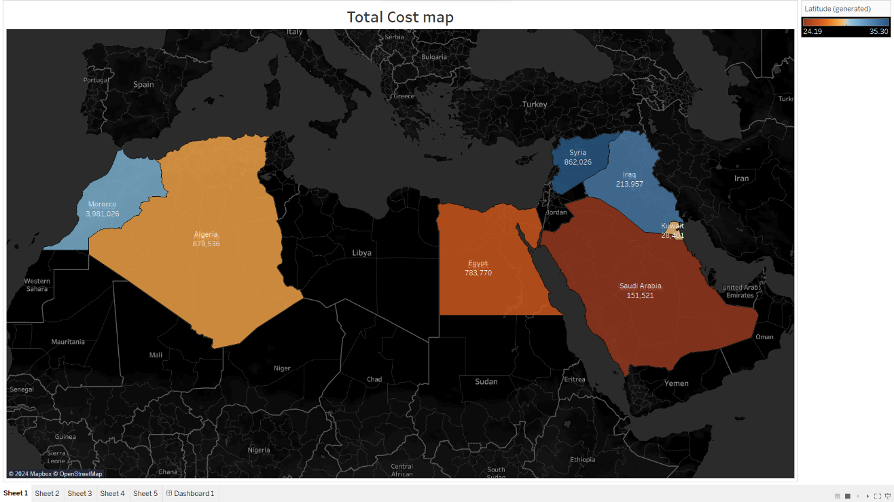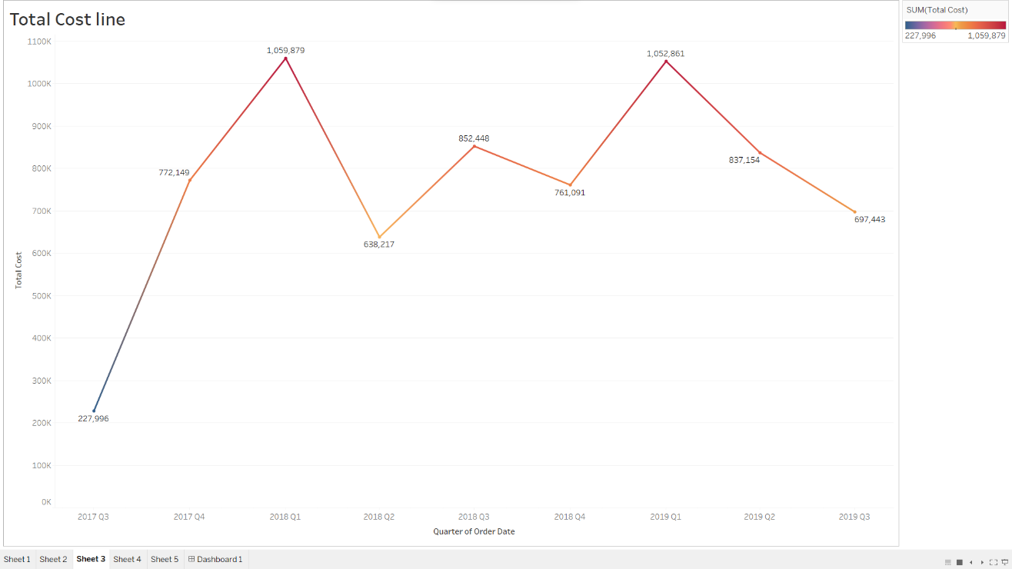Total Cost line chart

* Will manage and visualize the total cost throughout the years and see the downs and ups and analyze it.
* 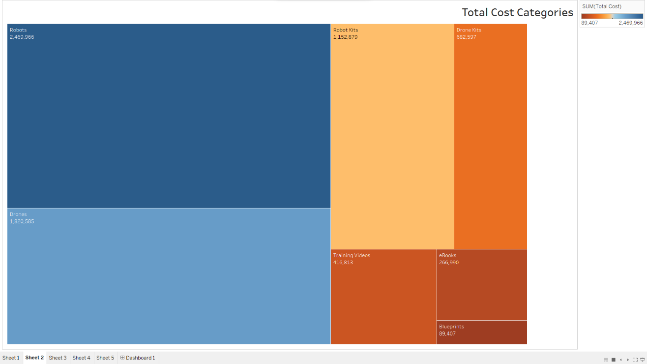Line chart – blue – red – gold colors – total cost legend.

Total Cost product categories

* Will help to decide which category need to be produced more and which need to be upgraded.
* Tree chart – Blue – orange colors – Product category name and total costs legends.

Total Cost map :

* Will help to decide which country has the higher sales in it and can help me to decide where to open a new branch.
* A screenshot of a computer

  Description automatically generatedMap chart – blue – red – orange colors – name of the country and total cost legends.

Company sales dashboard :

* Will decide where was the highest sales and when and which product and by which customers.